1)Installed nginx
ssh -i your-key.pem ec2-user@EC2_PUBLIC_IP
sudo yum update -y
sudo amazon-linux-extras install nginx1 -y
sudo systemctl start nginx
sudo systemctl enable nginx
Allow port 80 in Security Group
- Go to EC2 → Security Groups
- Edit inbound rules
Add:
  - HTTP → port 80 → 0.0.0.0/0

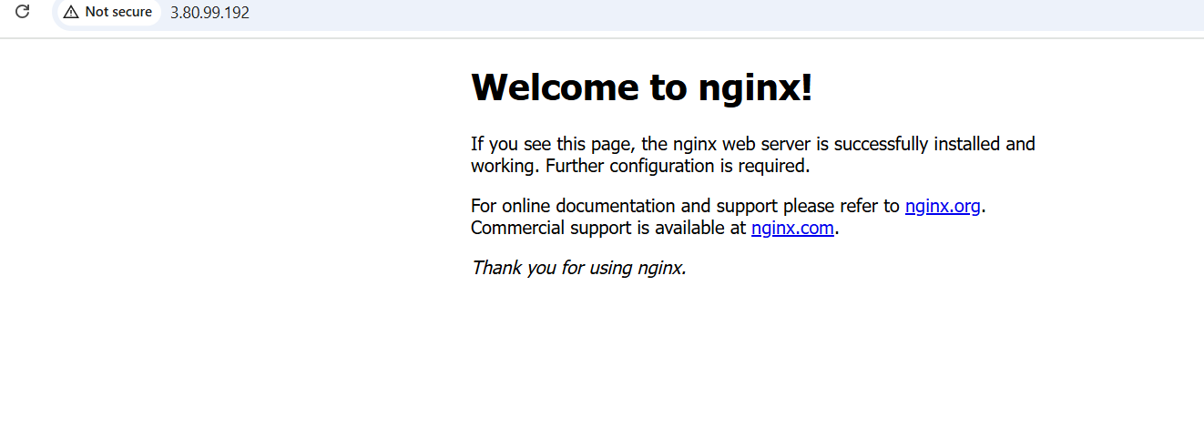
2)Running it on port 81
sudo vi /etc/nginx/nginx.conf
listen 80;
listen 81;
sudo systemctl restart nginx
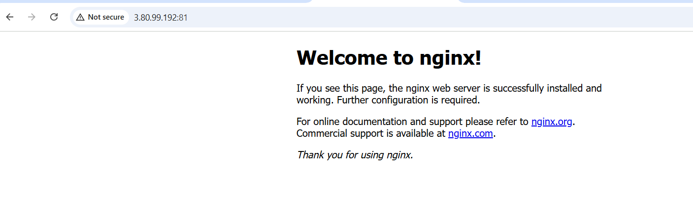
3) Deployed a sample index.html file

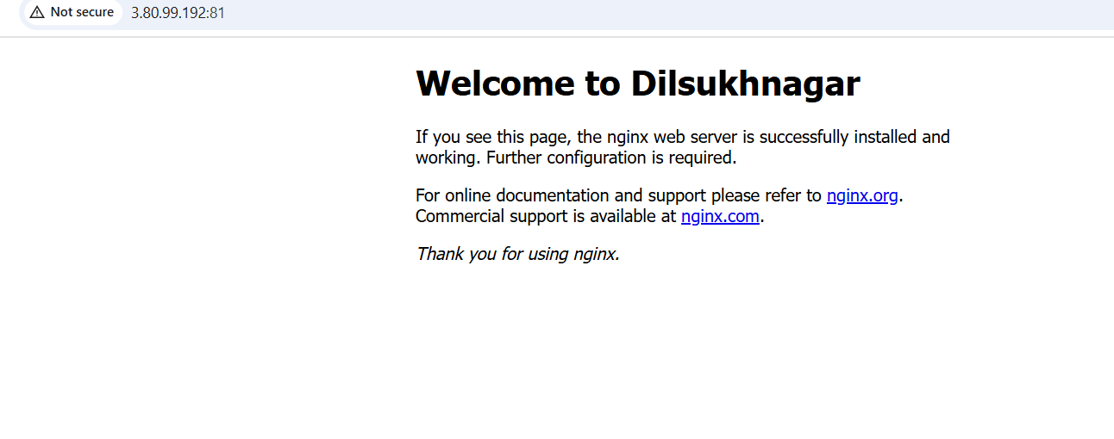
4)installed Apache
ssh -i your-key.pem ec2-user@EC2_PUBLIC_IP
sudo yum update -y
sudo yum install httpd -y
sudo systemctl start httpd
sudo systemctl status httpd
Open inbound rule:
- HTTP (port 80) → 0.0.0.0/0
http://EC2_PUBLIC_IP

5)Running Apache on port number 82
sudo vi /etc/httpd/conf/httpd.conf
Listen 80
Listen 82
sudo systemctl restart httpd
sudo systemctl status httpd
EC2 → Security Groups → Edit inbound rules
Add rule:
- Custom TCP
- Port: 82
- Source: 0.0.0.0/0
http://EC2_PUBLIC_IP:82

6) Deployed a sample index.html file

7)Installed Apache Tomcat
sudo yum update -y
sudo yum install java-11-openjdk -y
java -version
cd /opt
sudo wget https://downloads.apache.org/tomcat/tomcat-9/v9.0.93/bin/apache-tomcat-9.0.93.tar.gz
sudo tar -xvzf apache-tomcat-9.0.93.tar.gz
sudo mv apache-tomcat-9.0.93 tomcat9
sudo /opt/tomcat9/bin/startup.sh
ps -ef | grep tomcat
Go to:
EC2 → Security Groups → Inbound rules → Edit
Add:
- Custom TCP
- Port: 8080
- Source: 0.0.0.0/0
http://EC2_PUBLIC_IP:8080
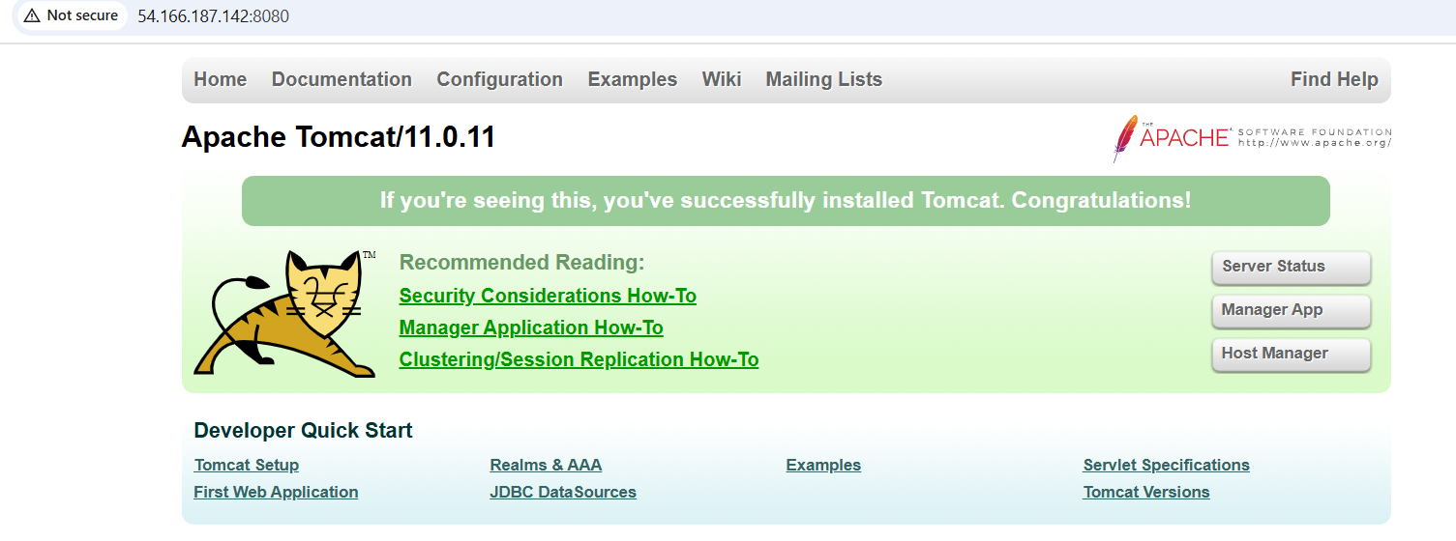
8) Deployed a sample app on Webapps
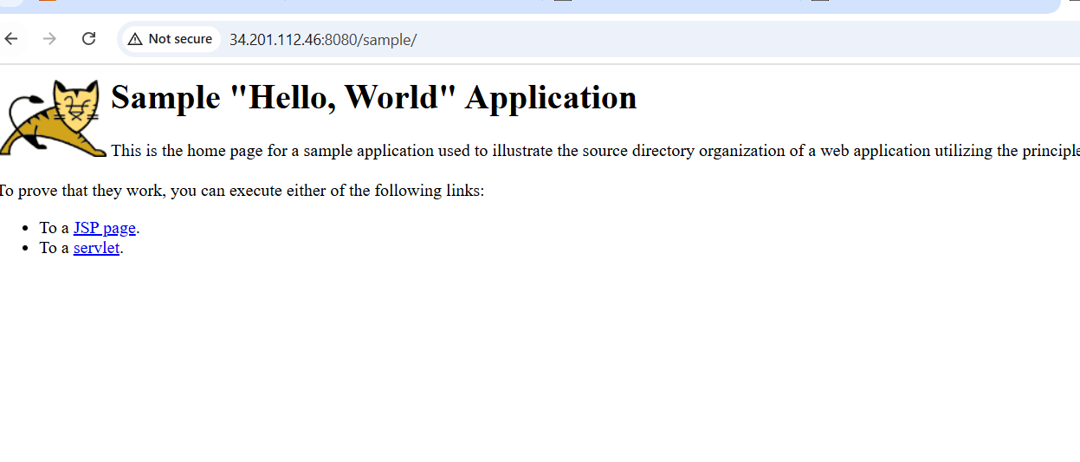
9)Ha-Proxy installation
